Propify

A place to buy, rent and sell property

UCS503 Software Engineering Project Report End-Semester Evaluation

**Submitted by:**

**(102203195) Rajveer Singh**

**(102203197)Gurleen Kaur**

**(102203201)Simrat Kaur**

**(102203205)Japneet Singh**

**BE Third Year- COE**

**Group No: 3CO-5 Team No: Team Name: Tech Titans**

**Submitted to:**

Vinod Bhalla Sir



**Computer Science and Engineering Department**

**TIET, Patiala November 2024**

TABLE OF CONTENTS

|  |
| --- |
| S.No. Assignment |
|  |
| 1. **Project Selection Phase** |
| * 1. Software Bid |
| * 1. Project Overview |
|  |
|  |
| 1. **Analysis Phase ( At least two significant cases of each UML Diagram)** |
| * 1. Use Cases |
| * + 1. Use-Case Diagrams |
|  |
| * + 1. Use Case Templates |
| * 1. Activity Diagrams and Swimlane Diagrams |
| * 1. Class Diagram |
| * 1. ER Diagram |
| * 1. Data Flow Diagrams (DFDs) |
| * + 1. DFD Level 0 |
| * + 1. DFD Level 1 |
| 1. **Software Requirement Specification in IEEE Format** |
| **4.Design Phase ( At least two significant cases of each diagram)** |
| 4.1 Class Diagram |
| 4.2 Sequence Diagram |
| 4.3 Collaboration Diagram |
| 4.4 State Chart Diagrams |
|  |
|  |
| 1. **Implementation**   5.1 Component Diagrams  5.2 Deployment Diagrams  5.3 Screenshots |
| 1. **Testing**   **6**.1 Test Plan  6.2 Test Cases  6.3 Test Reports |
|  |
|  |

1.Project Selection Phase

1.1 Software Bid

**Team Name: Tech Titans**

**Team ID (will be assigned by Instructor):**

|  |  |  |  |  |
| --- | --- | --- | --- | --- |
| Name | Roll No | Project Experience | Programming Language used | Signature |
| Rajveer Singh | 102203195 | 1.Crime Management System  2.Movie recommendation system | SQL,Python  PyCham |  |
| Gurleen Kaur | 102203197 | 1.Airline Database Management System  2.Amazon clone | SQL, Python, HTML, CSS, JS |  |
| Simrat Kaur | 102203201 | 1.Airline Database Management System  2.Facto website to share facts and information. | SQL, JS, Django, HTML, CSS |  |
| Japneet Singh | 102203205 | 1.Crime Management System  2.Personal portfolio website | SQL, HTMl, CSS, JS, React |  |

**Programming Language / Environment Experience**

1. HTML,CSS, JS

2. Node, Python

3. Django, MongoDB

**Choices of Projects:**

|  |  |  |
| --- | --- | --- |
|  | Project Name | Unique Selling Point |
| First Choice | **Propify**  Tech Stack- HTML,CSS, JS, MongoDB, Node, Django, Python  Description- Our project is a comprehensive real estate platform where users can buy and sell houses, flats, and plots, featuring a sleek frontend, robust backend, and an integrated chatbot for seamless user interaction and query resolution. This website ensures a smooth and efficient property transaction experience. | The USP (Unique Selling Proposition) of our project is its combination of a user-friendly interface with a powerful backend, coupled with an integrated chatbot that provides real-time support and personalized assistance, making property transactions smoother, faster, and more accessible than ever before. This seamless blend of technology and customer service sets your platform apart in the real estate market. |
| Second Choice | **InternHub**  Tech Stack- HTML,CSS, JS, MongoDB, Node, Django  Description- InternHub is a seamless platform that connects college students with tailored internship opportunities, simplifying the journey from education to career. Empower your future by discovering, applying, and securing internships that match your ambitions on InternHub. | InternHub's USP is its personalized internship matching system, which connects students with opportunities tailored to their skills and ambitions, streamlining the process of finding and securing the perfect internship. |
| Third Choice | **BiteExpress**  Tech Stack- HTML,CSS, JS, MongoDB, Node, Django, Google API  The project is a dynamic food delivery website for **SavoryBite**, featuring a comprehensive menu and an integrated chatbot for seamless ordering and customer support, ensuring a convenient and delightful dining experience. | The USP of **BiteExpress** is its seamless integration of a detailed restaurant menu with an interactive chatbot, providing users with instant support and personalized assistance to enhance the food ordering experience. |
| Fourth Choice | **FindIt**  Many students neglect submitting found items to the 'Lost & Found' department, leading to a higher number of lost items than found. Our AI-driven model simplifies the process by allowing users to upload photos and details of found items, with image recognition handling the rest, eliminating the need for constant email management and automatically deleting emails after ten days to free up space. | The USP of this lost and found website is its AI-driven image recognition system, which automates the matching process, eliminating the need for manual email management and ensuring faster, more efficient reunification of lost items with their owners. |

**Additional Remarks/ Inputs**

**Please tell us about any other factors that we should take into consideration (e.g., if you really would like to work on a project for some particularly convincing reason).**

When considering Propify, it's important to understand the challenges people face in the real estate market. Finding the right property that fits both location preferences and budget constraints can be overwhelming and time-consuming. We recognized this pain point and were driven to create a solution that not only simplifies the search process but also brings much-needed organization to the diverse and often chaotic real estate field. Our mission with Propify is to provide a streamlined, user-friendly platform that empowers individuals to find their ideal property with ease, ensuring transparency, convenience, and accessibility for all users. This project is not just about building a website; it's about transforming the real estate experience by making it more efficient, reliable, and customer-centric.

1.2 Project Write Up

**Project Name- Propify**

**Team No.**

**Write an executive summary. The executive summary serves as the introduction to your project proposal. ...**

When considering Propify, it's important to understand the challenges people face in the real estate market. Finding the right property that fits both location preferences and budget constraints can be overwhelming and time-consuming. We recognized this pain point and were driven to create a solution that not only simplifies the search process but also brings much-needed organization to the diverse and often chaotic real estate field. Our mission with Propify is to provide a streamlined, user-friendly platform that empowers individuals to find their ideal property with ease, ensuring transparency, convenience, and accessibility for all users. This project is not just about building a website; it's about transforming the real estate experience by making it more efficient, reliable, and customer-centric.

**Present a solution**

**P**ropify simplifies real estate by offering a user-friendly platform with advanced search filters, interactive property listings, and AI-driven assistance, making property discovery efficient, transparent, and accessible for all.

**Novelty/ Unique Selling Point-**

The USP (Unique Selling Proposition) of our project is its combination of a user-friendly interface with a powerful backend, coupled with an integrated chatbot that provides real-time support and personalized assistance, making property transactions smoother, faster, and more accessible than ever before. This seamless blend of technology and customer service sets your platform apart in the real estate market.

**Product Features**

* Enhanced Interactive and Robust Front-End
* Intuitive User Interface for Viewing and Purchasing Property with advanced search and filter system with options for location, price range, property type, etc.
* Scalable and Secure Backend in Django
* AI-Integrated Chatbot for User Assistance

**Define project deliverables/ Outcomes**

User-Centric Platform

* Outcome: Develop an intuitive and user-friendly interface that makes it easy for users to search, view, and purchase properties. The platform will be designed to cater to a wide range of users, from first-time buyers to experienced investors.

Advanced Search and Filter Capabilities

* Outcome: Implement a robust search engine with advanced filtering options, allowing users to customize their property search based on location, price, property type, and other key factors. This will reduce the time and effort required to find suitable properties.

Interactive Property Listings

* Outcome: Create interactive property listings that include detailed descriptions, high-quality images, virtual tours, and geolocation features. This will provide users with a comprehensive view of each property, helping them make informed decisions.

AI-Driven Chatbot

* Outcome: Deploy an AI-powered chatbot capable of answering user queries, providing property recommendations, and guiding users through the platform. The chatbot will enhance user engagement and improve the overall customer experience.

Scalable and Secure Backend

* Outcome: Develop a robust backend using Django, ensuring the platform can handle a high volume of users and transactions. Security measures such as role-based access control, data encryption, and secure authentication will be implemented to protect user data.

**Look and Feel of Product/ Product Perspective**

Propify offers a modern, clean, and visually appealing interface that balances aesthetics with functionality. The design is intuitive, with a focus on user experience, ensuring ease of navigation and quick access to key features. The color scheme is elegant and professional, reflecting trust and sophistication, while the layout is organized to avoid clutter, providing a seamless browsing experience. Interactive elements, such as property cards, maps, and filters, are responsive and engaging, enhancing user interaction. The overall feel of Propify is sleek, welcoming, and tailored to make property discovery and transactions as smooth and enjoyable as possible.

**Scope of Application**

Propify is designed to revolutionize the real estate market by providing a comprehensive platform for property discovery, buying, and selling. The application caters to a wide audience, including individual buyers, sellers, real estate agents, and investors, offering advanced search capabilities, interactive property listings, and seamless transaction processes.

With its AI-integrated chatbot, Propify ensures personalized assistance and support, enhancing the user experience. The platform is accessible across various devices, ensuring a broad reach, and includes robust security features to protect user data and transactions.

Propify aims to streamline the real estate process, making it more efficient, transparent, and user-centric.

**Tech Stack to be used**

* HTML
* CSS
* DJANGO
* PYTHON
* JS
* BOOTSTRAP
* PYCham

**Timeline/ Gantt Chart**

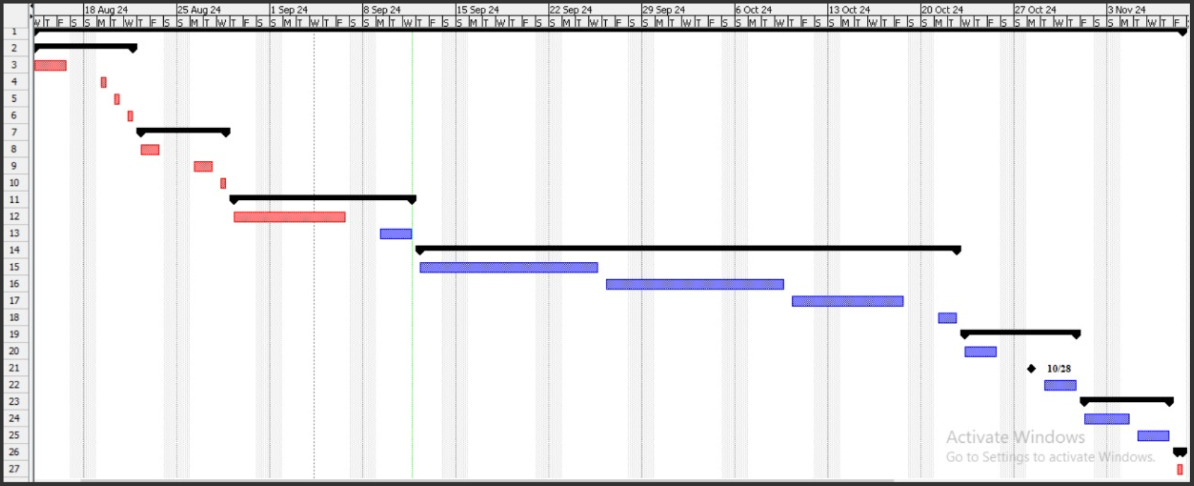

Fig 1.1 Gantt Chart

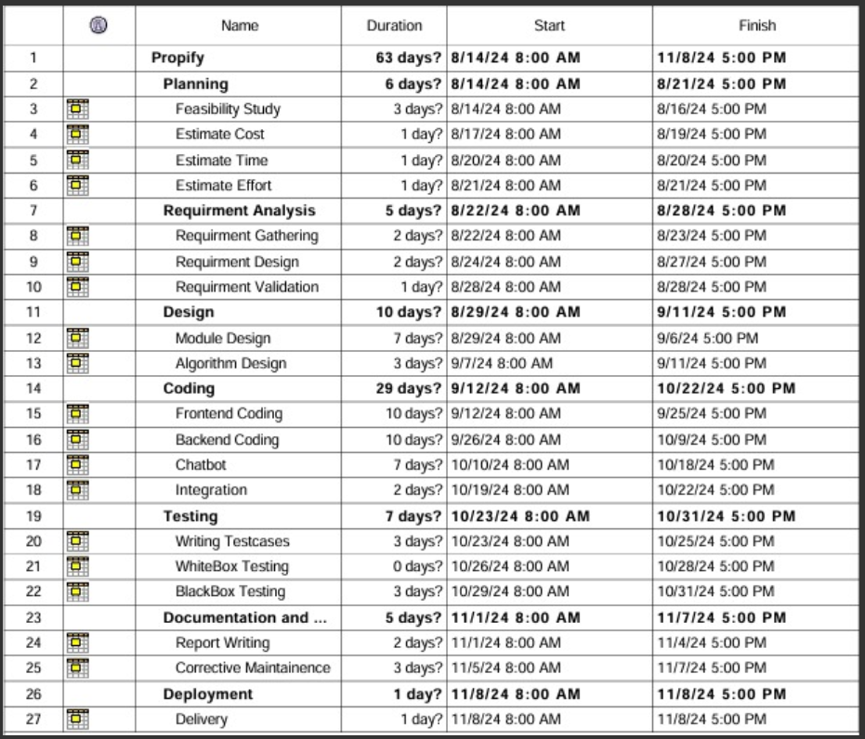

Fig 1.2

**2.Analysis Phase**

| **Use Case Title** | **Search Properties** |
| --- | --- |
| **Use Case ID** | **1** |
| **Actors** | **User (Buyer/Seller)** |
| **Description** | **The user can search for properties by entering specific search criteria, such as location, price range, property type, etc. The system displays a list of properties matching the search criteria.** |
| **Pre-Conditions** | **User must be logged into the system.**  **User has access to search filters for properties.** |
| **Task Sequence** | **User selects the search option.**  **User enters search criteria (location, price, type, etc.).**  **System retrieves and displays properties that match the criteria.** |
| **Post Conditions** | **A list of properties matching the criteria is displayed.**  **User can select a property to view more details or initiate a transaction.** |
| **Modification History** | **13-10-2024** |
| **Authors** | **Rajveer Singh,Japneet Singh,Gurleen Kaur,Simrat Kaur** |

**2.1 Use Cases 2.1.2 Use Case Templates**

**2.1.2 Use case Diagrams**

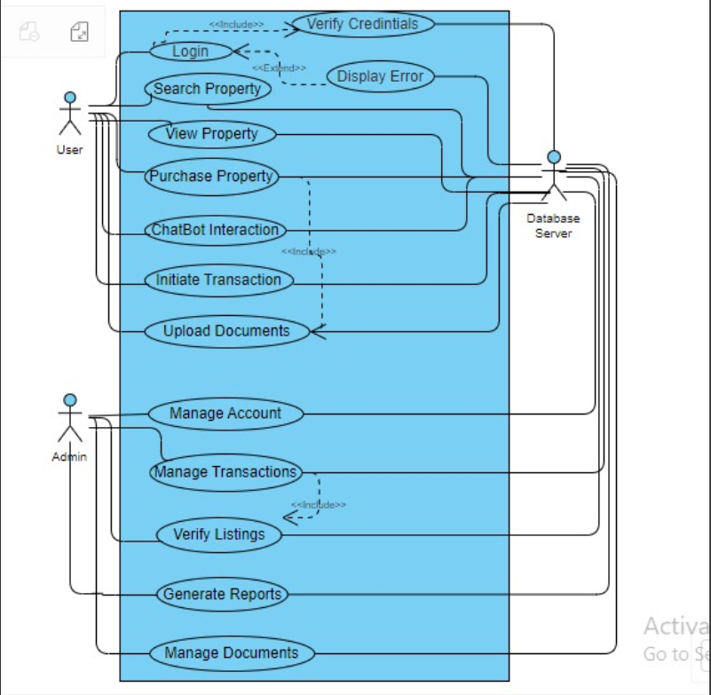

Fig 1.3 Use Case diagram

**2.2 Activity Diagrams**

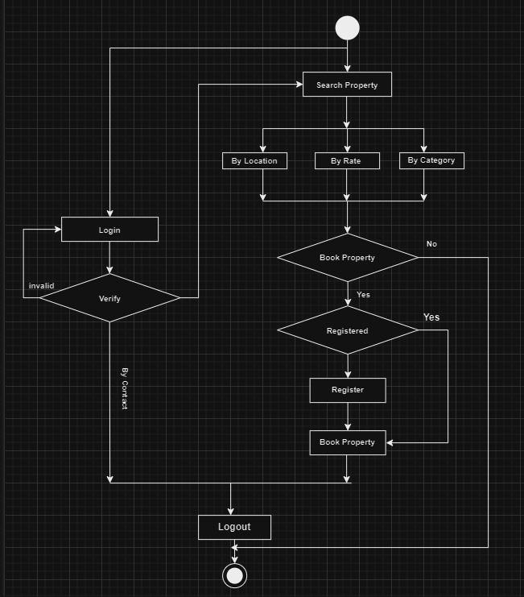

Fig 1.4 Activity Diagram

**2.4 ER Diagram**

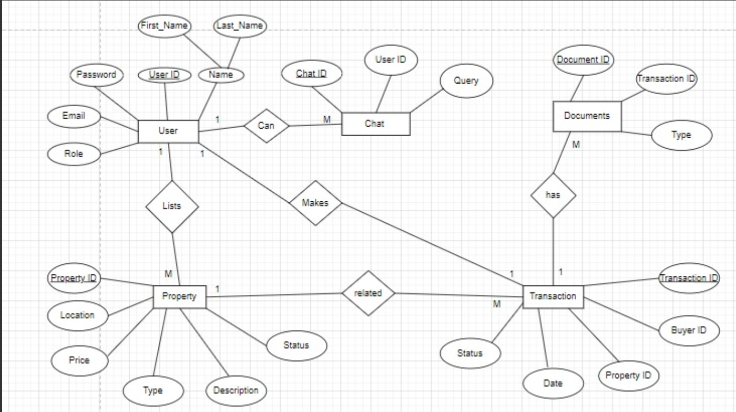

Fig 1.5 ER diagram

**2.5 Data Flow Diagrams (DFD’s)**

**2.5.1 DFD level 0**

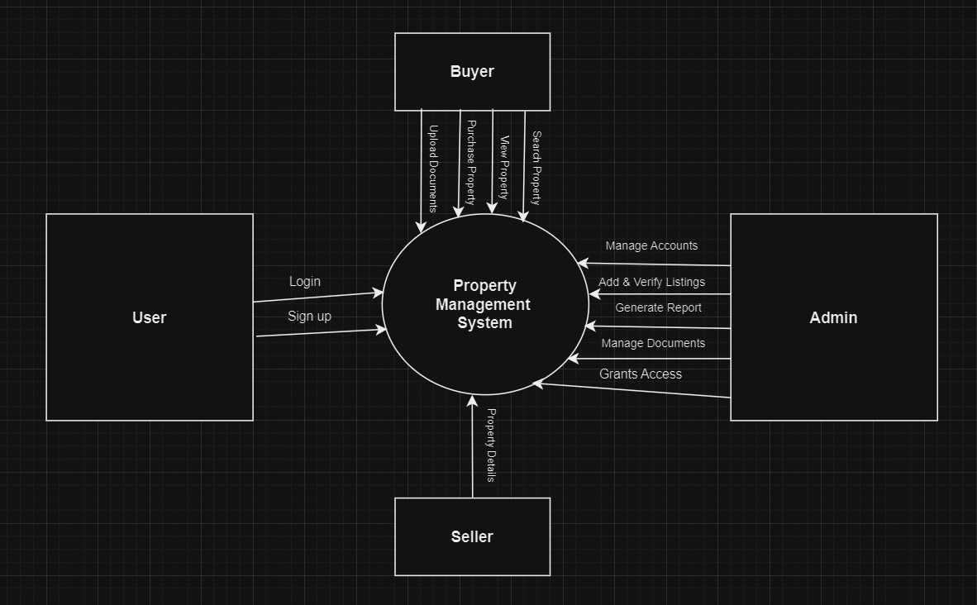

Fig 2.1 DFD Level-0

**2.5.2 DFD level 1**

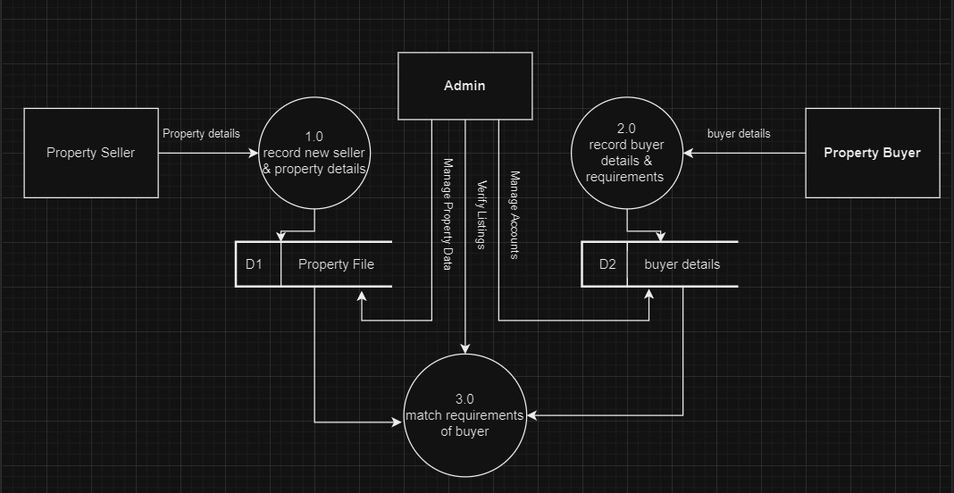

Fig 2.2 DFD level-1

**3.Software Requirement Specification in IEEE Format**

A CASE STUDY (IEEE Format)

|  |  |
| --- | --- |
|  |  |
|  |  |

Software Requirements Specification Document

**Version 1.0**

***Propify***



|  |  |
| --- | --- |
|  |  |
|  |  |

TABLE OF CONTENTS

# Chapter No. Topic Page No.

# 1. Introduction 3

# 1.1 Purpose of this Document 3

# 1.2 Scope of the Development Project 3

# 1.3 Definitions, abbreviations and acronyms 5

# 1.4 References 6

# 1.5 Overview 7

# 2. Overall Description 7

# 2.1 Product Perspective 7

# 2.2 Product functions 10

# 2.3 User Characteristics 10

# 2.4 General Constraints, Assumptions and Dependencies 11

# 2.5 Apportioning of the requirements 12

# 3. Specific Requirements 13

# 3.1 External Interface Requirements 13

# 3.2 Detailed Description of Functional Requirements 14

# 3.2.1 Functional Requirements for Client Welcome Screen 14

# 3.2.2 Functional Requirements for Legal Advisor Screen 15

# 3.2.3 Functional Requirements for Client cum 15

# Legal Advisor Welcome 15

# 3.3 Performance requirements 16

# 3.4 Logical database requirements 16

# 3.5 Quality attributes 17

# 3.6 Other requirements 17

# 4 Change History 17

# 5 Document Approvers 17

# **1.** **Introduction**

### **1.1** **Purpose of this Document**

The purpose of this SRS document is to provide a detailed overview of our software product, its parameters and goals. This document describes the project's target audience and its user interface, hardware and software requirements. It defines how our client, team and audience see the product and its functionality.

**1.2**  **Scope of the Development Project**

The scope of Propify includes developing a user-friendly real estate platform with advanced search filters, interactive property listings, AI-powered chatbot support, and a scalable backend built on Django. It will cater to buyers, sellers, and agents, providing seamless property discovery and secure transactions while enhancing user experience through personalised assistance and intuitive navigation across various devices.The software must be able to perform the following operations:-

**1. Advanced Property Search and Filtering**: Users can search properties with filters based on location, price, property type, and more, ensuring a personalised experience.

**2. Interactive Property Listings**: Each listing includes high-quality images, descriptions, virtual tours, and geolocation to provide a complete view of the property.

**3. AI-Powered Chatbot**: Real-time assistance for users with property recommendations, query resolution, and navigation support.

**4**. **Secure Transactions and Document Management**: Facilitates safe property transactions with secure document handling, ensuring compliance with legal and financial standards.

**5. Scalability and Expansion**: Initially launched for a select group of users, with future plans to integrate more features like market analysis, mortgage calculators, and support for commercial properties.

**Summary:**

Propify offers a comprehensive and scalable real estate platform that simplifies property search, buying, and selling. By combining advanced technology, user-friendly design, and AI-driven support, it ensures seamless transactions and personalised experiences, with plans for further feature expansion.

### **1.3** **Definitions, Abbreviations and Acronyms**

**Definitions**

It gives explanation of the most commonly used terms in this SRS document.

**1. Advanced Property Search:** A powerful search engine with filters for location, price, property type, and other criteria, helping users find properties that match their needs.

**2.Interactive Property Listing**: Detailed listings featuring high-quality images, descriptions, virtual tours, and geolocation, giving users a comprehensive view of each property.

**3**. **AI-Powered Chatbot**: A real-time assistant that provides property recommendations, answers queries, and guides users through the platform with personalised assistance.

**4.** **Secure Transactions**: Safe and compliant handling of property transactions, ensuring secure documentation and financial data processing for buyers and sellers.

**5. Scalable Backend**: A robust Django-based backend designed to handle a growing number of users and property listings, ensuring seamless performance and scalability.

**6.** **Personalised Recommendations**: Customised property suggestions based on user preferences, search history, and market trends, enhancing the overall user experience.

**7.** **Real-Time Support**: Immediate assistance through chatbots for customer support, offering a seamless property transaction experience at any time of day.

**8.** **User-Friendly Interface**: A simple, intuitive design that enables users to easily navigate, search for properties, and complete transactions with minimal effort.

**Abbreviations**

Table 2 gives the full form of most commonly used mnemonics in this SRS document.

**Table 2: Full form for most commonly used mnemonics**

|  |  |  |
| --- | --- | --- |
| **S. No.** | **Mnemonic** | **Full Form** |
| 1 | APS | Advanced property search |
| 2 | IPL | Interactive Property Listings |
| 3 | AIC | AI-Powered Chatbot |
| 4 | ST | Secure Transactions |
| 5 | SB | Scalable Backend |
| 6 | PR | Personalised Recommendations |
| 7 | RTS | Real-Time Support |
| 8 | UFI | User Friendly Interface |

### 

### **1.4** **References**

**[1]. Simplified Property Search**[*https://www.zillow.com/property-search-guide*](https://www.zillow.com/property-search-guide)

**[2]. Personalised Property Recommendations**[*https://www.forbes.com/sites/forbestechcouncil/2023/02/15/how-ai-is-revolutionizing-real-estate-searches*](https://www.forbes.com/sites/forbestechcouncil/2023/02/15/how-ai-is-revolutionizing-real-estate-searches)

**[3]. Transparent Pricing Models**[*https://www.inman.com/2022/11/02/why-transparent-pricing-is-essential-for-the-future-of-real-estate*](https://www.inman.com/2022/11/02/why-transparent-pricing-is-essential-for-the-future-of-real-estate)

**[4]. Cutting-Edge Real Estate Technology**[*https://www.techrepublic.com/article/real-estate-tech-trends-2023/*](https://www.techrepublic.com/article/real-estate-tech-trends-2023/)

**[5]. Fast and Efficient Property Search**[*https://realtyna.com/blog/importance-real-estate-search-speed-2022*](https://realtyna.com/blog/importance-real-estate-search-speed-2022)

**[6]. Data Security and Privacy in Property Transactions**[*https://www.realtor.com/advice/finance/how-to-protect-your-financial-information-when-buying-a-home/*](https://www.realtor.com/advice/finance/how-to-protect-your-financial-information-when-buying-a-home/)

**[7]. 24/7 AI-Driven Chatbot Assistance**[*https://chatbotsmagazine.com/how-ai-chatbots-are-revolutionizing-customer-service-3c2b5d3d6e70*](https://chatbotsmagazine.com/how-ai-chatbots-are-revolutionizing-customer-service-3c2b5d3d6e70)

**[8]. Property Management Dashboard**[*https://www.housingwire.com/articles/modern-property-management-tools-to-watch/*](https://www.housingwire.com/articles/modern-property-management-tools-to-watch/)

**[9]. Automation in Property Transactions**[*https://www.forbes.com/sites/forbestechcouncil/2022/08/30/automation-in-real-estate-transactions/*](https://www.forbes.com/sites/forbestechcouncil/2022/08/30/automation-in-real-estate-transactions/)

**[10]. Artificial Intelligence in Real Estate**[*https://www.realestateagent.com/blog/how-ai-is-changing-the-real-estate-industry/*](https://www.realestateagent.com/blog/how-ai-is-changing-the-real-estate-industry/)

**[11]. Real Estate Technology Trends**[*https://www.forbes.com/sites/forbestechcouncil/2022/11/14/the-future-of-real-estate-technology/*](https://www.forbes.com/sites/forbestechcouncil/2022/11/14/the-future-of-real-estate-technology/)

**[12]. Real Estate Digitization and Online Services**[*https://www.mckinsey.com/industries/real-estate/our-insights/the-2023-real-estate-technology-outlook*](https://www.mckinsey.com/industries/real-estate/our-insights/the-2023-real-estate-technology-outlook)

### 

### 

### **1.5** **Overview**

The remaining sections of this document provide a general description, including characteristics of the users of this project, the product's hardware, and the functional and data requirements of the product. General description of the project is discussed in section 2 of this document. Section 2 gives the functional requirements, data requirements and constraints and assumptions made while designing the multi-utility system. It also gives the user viewpoint of product use. Section 3 gives the specific requirements of the product. Section 3.0 also discusses the external interface requirements and gives detailed description of functional requirements.

**2.** **Overall Description**

**2.1 Product Perspective**

**1. Introduction**

Propify is an innovative web-based platform designed to streamline the process of buying and selling real estate properties. The platform aims to bridge the gap between property seekers and sellers by leveraging modern web technologies. Propify provides users with a comprehensive solution to search, view, and engage with properties while accessing valuable real estate information through an AI-driven chatbot.

**2. System Overview**

Propify will function as a centralised hub where users can:

Search for properties based on their specific preferences, including location, price range, and property type.

View detailed listings that include high-quality images, descriptions, virtual tours, and user reviews.

Book viewings and engage in direct communication with sellers or agents via chat and video calls.

Access an AI-powered chatbot to answer general real estate questions and provide information on the buying and selling processes relevant to the user’s location.

**3. Stakeholders**

Buyers: Individuals or families looking to purchase properties, using the platform to find and interact with listings.

**Sellers:** Property owners looking to sell their properties, who will list their properties and manage inquiries through the platform.

**Real Estate Agents:** Professionals who will assist in property transactions and provide their services on the platform.

**Admin:** Platform administrators responsible for managing user accounts, monitoring interactions, and ensuring the smooth operation of the website.

**Developers:** The technical team responsible for building and maintaining the website and its features.

**4. Technologies and Tools:**

**Front-End Technologies:**

HTML/CSS/JavaScript/Bootstrap: For building the user interface and ensuring responsiveness.

React.js/Django Templates: For creating a dynamic and interactive user experience.

**Back-End Technologies:**

Django/Python: For server-side logic and API development.

**Database**:

PostgreSQL/MySQL: For handling structured data related to properties and user interactions.

**Communication Tools:**

WebRTC: For enabling real-time video calls.

Socket.io: For real-time chat functionalities.

**Chatbot Technology:**

Dialog flow/Botpress: For developing and managing the AI-driven chatbot to assist users with property-related queries.

AWS/Azure/Google Cloud: For hosting the application, ensuring scalability.

Docker/Kubernetes: For containerization and orchestration.

**5.** **Integration**

Payment Gateway: Integration with payment systems for handling booking fees or transaction payments, if applicable.

Authentication Services: Implementing secure login mechanisms and user management features to protect user data and ensure privacy.

### **2.1** **Product Functions**

### The product should be able to perform the following operations:

1. **Real-Time Property Consultation**: Enables users to connect with real estate agents or sellers for instant, personalised assistance via chat or video call, available 24/7.

2. **Advanced Property Recommendations**: Provides tailored property suggestions based on individual user preferences, including location, budget, and property type, ensuring personalised property discovery.

3. **Transparent Pricing Display**: Shows clear, upfront pricing information for all listed properties, including any associated fees, allowing users to understand costs before engaging in transactions.

4. **Automated Listing Management**: Manages property listings efficiently with features such as document storage, progress tracking for viewings, and automated reminders for important deadlines and tasks.

5. **Secure Communication Channels**: Facilitates secure and encrypted communication between users and real estate agents or sellers, ensuring the confidentiality and protection of sensitive property information.

### **2.2** **User Characteristics**

The goal is to design software for Propify, a comprehensive real estate platform that includes 24/7 access to property listings, personalised property recommendations, transparent pricing, and secure communication. This will enhance user support and satisfaction. The user types are listed below:

1. Buyer

2. Seller

3. Real Estate Agent

4. System Administrator

5. Billing and Accounts Personnel

6. Data Privacy Officer

As observed from the list, each user will have different educational backgrounds and levels of expertise in using the system. Our goal is to develop software that is easy to use for all types of users, including first-time property buyers and experienced real estate professionals. Thus, while designing the software, one can assume that each user type has the following characteristics:

⮚ The user is computer-literate and has little or no difficulty accessing the website over the internet.

⮚ It is not required for users to be aware of the internal workings of the software to use its features effectively.

### **2.3** **General Constraints, Assumptions and Dependencies**

**Legal Compliance and Data Protection**: Propify must adhere to regional property laws and data protection regulations (e.g., GDPR) to ensure user privacy and secure transactions.

**24/7 Availability via AI Chatbot:** While Propify’s AI-driven chatbot provides round-the-clock support, responses to more complex inquiries may depend on data availability and the AI's capacity to handle detailed questions.

**Jurisdictional Limitations**: The platform’s services, including property listings and transaction support, are limited to regions where Propify can legally operate, adhering to local property regulations.

**Technology Infrastructure and Cybersecurity:** Propify relies on a scalable and secure infrastructure, including cloud services and encrypted communication channels, to manage sensitive user data and property transactions.

**Accurate Property Listings and Transparency:** All property listings on Propify must be regularly updated for accuracy, with transparent pricing and fee structures to ensure trust and clarity for users.

**User Access to Technology**: Users must have reliable internet access and devices (e.g., smartphones, computers) to effectively search, view, and purchase properties on Propify.

**Dependency on Real Estate Databases and AI**: Propify’s advanced search and AI-powered recommendations depend on up-to-date access to property databases and the efficiency of AI algorithms to deliver relevant results.

**Scalability and Server Load Management**: The platform must be designed to handle high volumes of users and transactions during peak times, without compromising performance or user experience.

### 

### 

### **2.4** **Apportioning of requirements**

Development Phases for Lawise Expert Legal Advisory System

Phase 1: Core Functionality Development

Focus on building essential features such as user registration, property search with advanced filters, user-friendly property listing management, appointment scheduling for viewings, secure communication tools, and a basic AI-driven chatbot for initial user support.

Phase 2: Integration with External Real Estate and Financial Systems

Integrate Propify with external real estate databases, payment gateways, and property management platforms. Develop APIs for third-party integration to facilitate seamless interactions between buyers, sellers, and real estate agents.

Phase 3: Advanced Features and AI Integration  
 Implement AI-driven property recommendations, automated document generation for transactions, virtual tours, and predictive analytics for property valuation. Enhance the chatbot to provide personalised property suggestions and real-time assistance.

Phase 4: Testing and Deployment

Conduct comprehensive security, performance, and usability testing to ensure the platform meets industry standards and user expectations. After successful testing, deploy the platform to the production environment.

Phase 5: Post-Deployment Support and Maintenance

Monitor the platform for issues post-deployment, implement regular updates to enhance features and security, fix bugs, and gather user feedback to continuously improve the user experience and functionality of Propify.

# **3.** **Specific Requirements**

#### **3.1** **External Interface Requirements**

1. **User-Friendly Client Portal:** A secure, intuitive platform that allows users to easily search for properties, view detailed listings, manage their preferences, and communicate with real estate agents.
2. **24/7 AI Chatbot and Live Support System:** An AI-driven chatbot that provides instant responses to user inquiries, with the ability to escalate to live agents for more complex or urgent property-related questions at any time.
3. **Pricing Transparency Module:** An interface that provides a clear breakdown of property prices, including fees and taxes, an interactive cost calculator for estimating total costs, and straightforward payment options with no hidden fees.
4. **Advanced Property Management Tools:** A secure cloud-based system for sharing property-related documents, collaborative features for buyers and sellers, e-signature functionality for transactions, and version tracking with encryption to ensure privacy and security of sensitive information.
5. **Interactive Property Listings:** Listings that include high-quality images, virtual tours, detailed descriptions, and geolocation features to enhance the user's property search experience.
6. **Advanced Search and Filter Options:** Users can customise their property searches with advanced filters for location, price range, property type, and additional features (e.g., number of bedrooms, square footage).
7. **User Feedback and Rating System:** A mechanism for users to leave feedback and ratings for properties and agents, helping to build trust and improve the quality of listings.
8. **Mobile Responsiveness:** The platform must be fully functional and user-friendly across various devices, including smartphones, tablets, and desktops, ensuring a seamless user experience.

### **3.2** **Detailed Description of Functional Requirements**

**3.2.1 Describes functional requirements**

|  |  |  |  |
| --- | --- | --- | --- |
| Purpose | Inputs | Processing | Outputs |
| A description of the functional requirements and their reasons | What are the inputs; in what form will they arrive; from what sources can the inputs come; what are the legal domains of each input? | Describes the outcome rather than the implementation; includes any validity checks on the data, exact timing of operation (if needed), and how to handle unexpected or abnormal situations. | The form, shape, destination, and volume of output; output timing; the range of parameters in the output; unit of measure of the output; the process by which output is stored or destroyed; process for handling error messages produced as output. |

**Table 3: Describes functional requirements**

**3.2.2** **Functional Requirements for Client Welcome Screen**

|  |  |  |  |  |
| --- | --- | --- | --- | --- |
| Functional Requirement | Purpose | Inputs | Processing | Outputs |
| Client Welcome Screen | Provides a single interface for clients who are both buyers and sellers, allowing them to access personal property listings and manage their transactions effectively. | - Queries related to personal property searches  - Offers to sell or buy property  - Document uploads for property transactions | Dynamically responds to user selections, displaying either personal property listings for buying/selling or details about their current transactions. | - Screens showing personalised property listings  - Transaction status updates  - Example: Selecting a option may display current properties available for purchase; selecting another option shows details about properties listed for sale. |

**Table 4: Functional Requirements for Client Welcome Screen**

#### 

#### 

#### 

#### 

#### 

#### 

#### 

#### 

#### 

#### 

#### 

#### **3.2.2** **Functional Requirements for Admin Welcome Screen**

|  |  |  |  |  |
| --- | --- | --- | --- | --- |
| Functional Requirement | Purpose | Inputs | Processing | Outputs |
| Admin Welcome Screen | Provides a single interface for administrators to manage the platform's users, property listings, and transactions efficiently. | - User queries related to account management  - Property listing approvals/rejections  - Transaction management inputs  - Reports on platform activity | Dynamically responds to admin selections, offering options to approve/reject listings, manage users, oversee transactions, and generate reports. | - Screens showing property listing statuses (approved/rejected/pending)  - User management screens  - Reports on platform performance and transaction summaries |

**Table 5: Functional Requirements for Admin Welcome Screen**

**3.3 Performance Requirements**

● **Online-Only Access**:

Propify operates exclusively online, providing users with seamless access to property listings and services from any device connected to the internet, rather than relying on standalone PCs.

● **24/7 Availability**:

The platform ensures round-the-clock availability through robust server infrastructure and load balancing, providing uninterrupted access to property information and assistance.

● **AI-Driven Personalization**:

Propify utilises AI-driven personalization to deliver tailored property recommendations based on user preferences, efficiently processing varying amounts of data to enhance the user experience.

● **Concurrent User Support**:

The system is designed to support multiple users simultaneously, ensuring consistent performance and responsiveness across different terminals without degradation in service quality.

● **Fast Load Times**:

The application must maintain quick load times for property listings and search results, ideally under three seconds, to ensure a smooth and efficient user experience.

● **Scalability**:

The platform should be scalable to accommodate an increasing number of users and property listings without compromising performance, ensuring that future growth can be supported effectively.

### **3.4** **Logical Database Requirements**

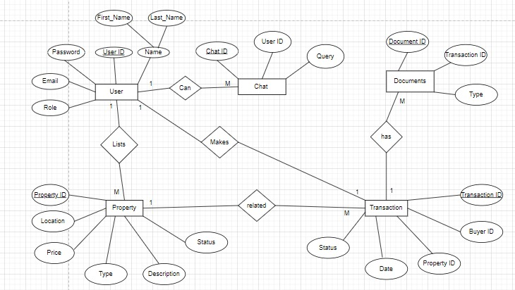

Figure 3.1: E-R Diagram for the entire system

### **3.5** **Quality Attributes**

Propify is an innovative real estate platform designed to simplify the property buying and selling process for users. With a user-friendly interface and advanced search capabilities, it provides a seamless experience for finding properties. The platform is accessible 24/7, ensuring that users can browse listings and receive personalised assistance through an AI-driven chatbot at any time. Propify leverages cutting-edge technology to ensure fast response times, high availability, and robust security for all transactions. Built to be scalable and error-tolerant, it accommodates a growing number of users and properties while protecting sensitive user data, ensuring a reliable and efficient real estate experience across multiple devices.

**3.6** **Other Requirements**

● Size (Line of Code)

● Business Rules

**●** Good network bandwidth

# **4.** **Change History**

|  |  |
| --- | --- |
|  |  |
|  |  |

### **5.** **Document Approvers**

SRS for Propify approved by:

Name: Vinod Bhalla Sir

Designation: Teaching Assistant, Thapar Institute of Engineering and Technology

Date:

**4. Design Phase ( At least two significant cases of each diagram)**

4.1 Class Diagram

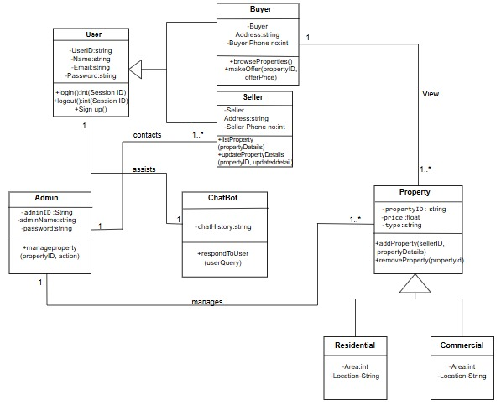

Fig 41. Class Diagram

4.2 Sequence Diagram

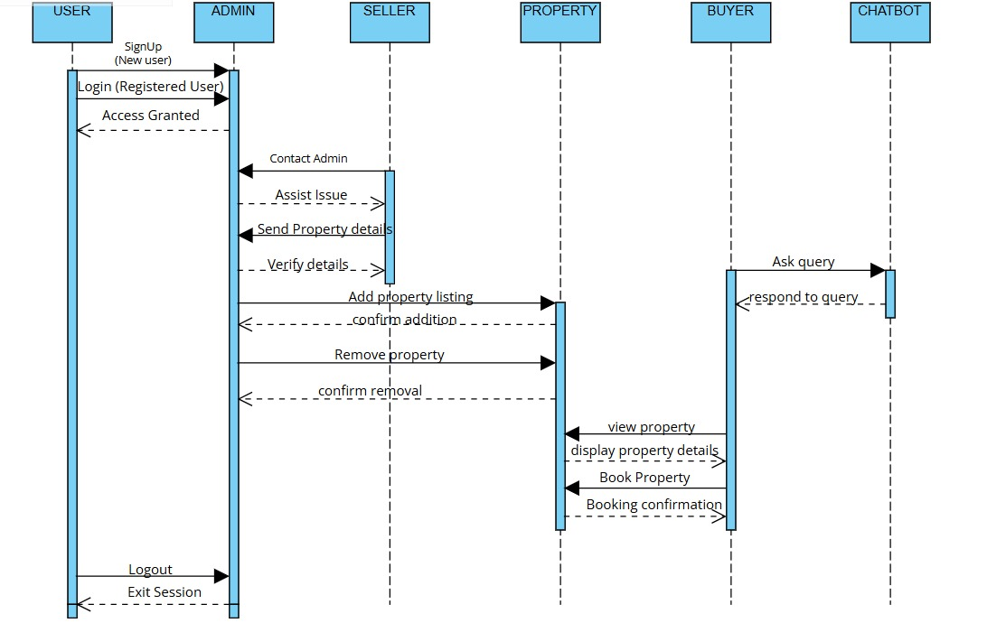

Fig 4.2- Sequence Diagram

4.3 Collaboration Diagram

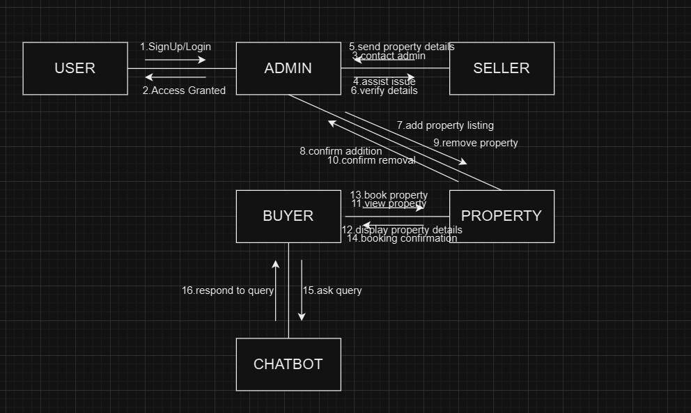

Fig 4.3 Collaboration Diagram

4.4 State Chart Diagrams

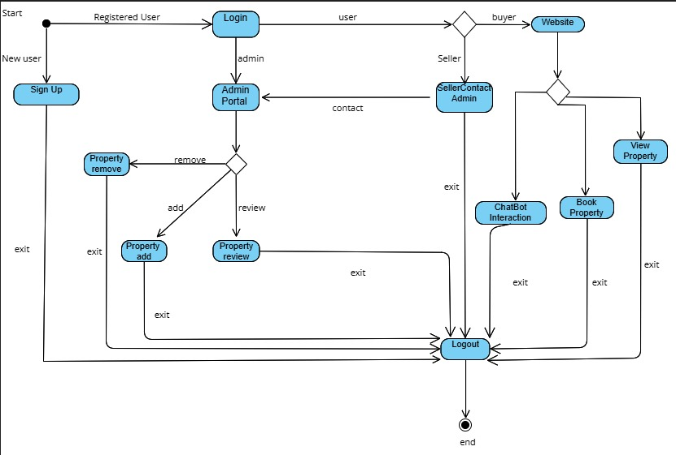

Fig 4.5 State Chart Diagram

1. **Implementation**
   1. Component Diagrams

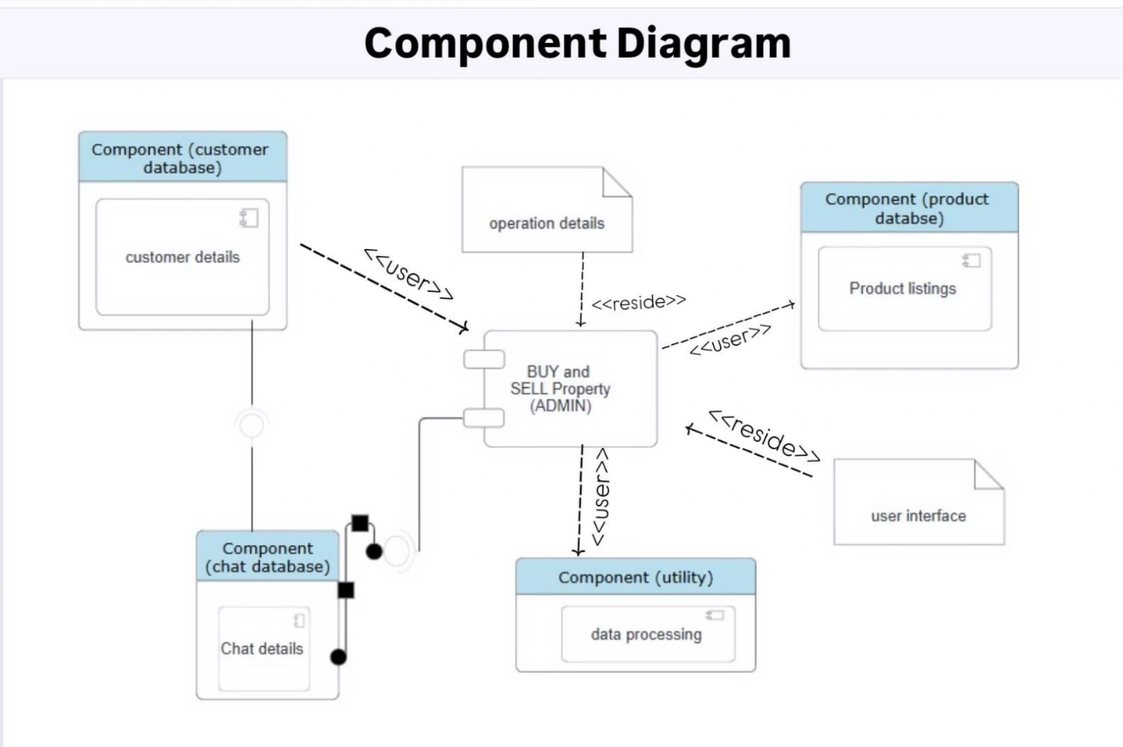Fig 5.1 Component Diagram

* 1. Deployment Diagrams

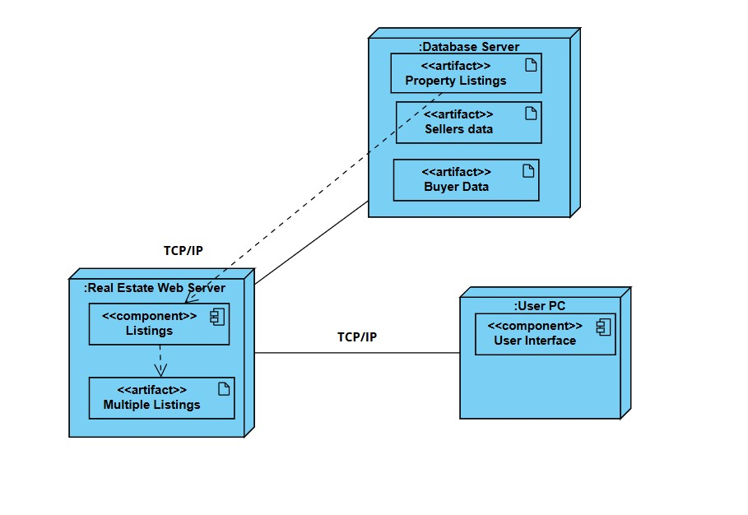

Fig5.2 Deployment Diagram

* 1. Screenshots

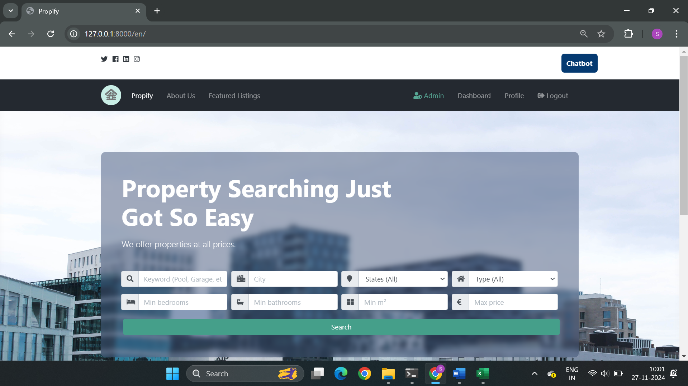

Fig 5.3 Home page

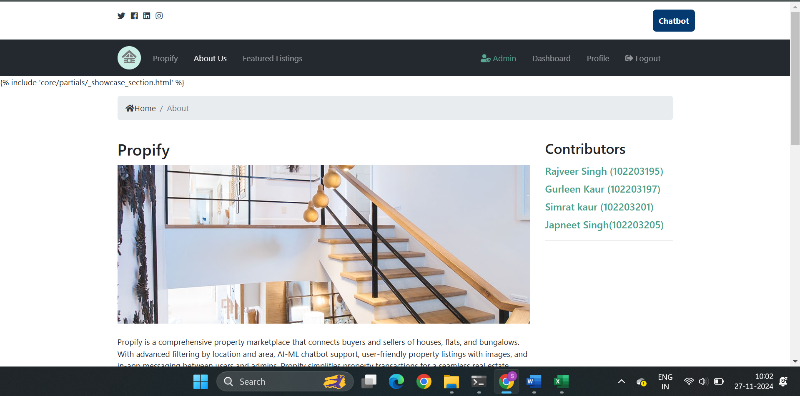

Fig 5.4 About us

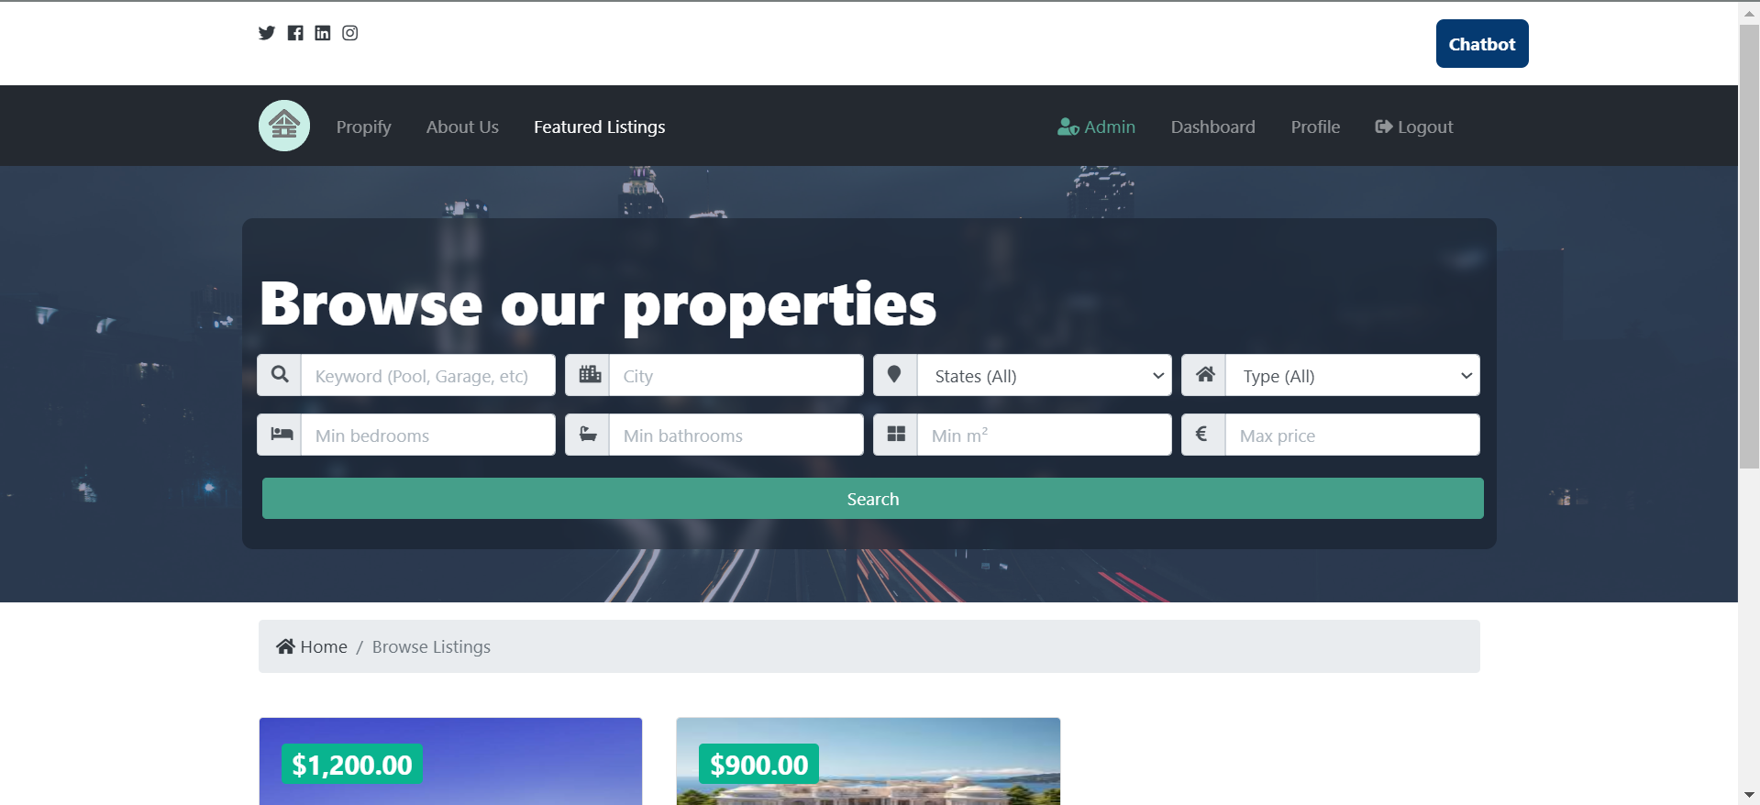

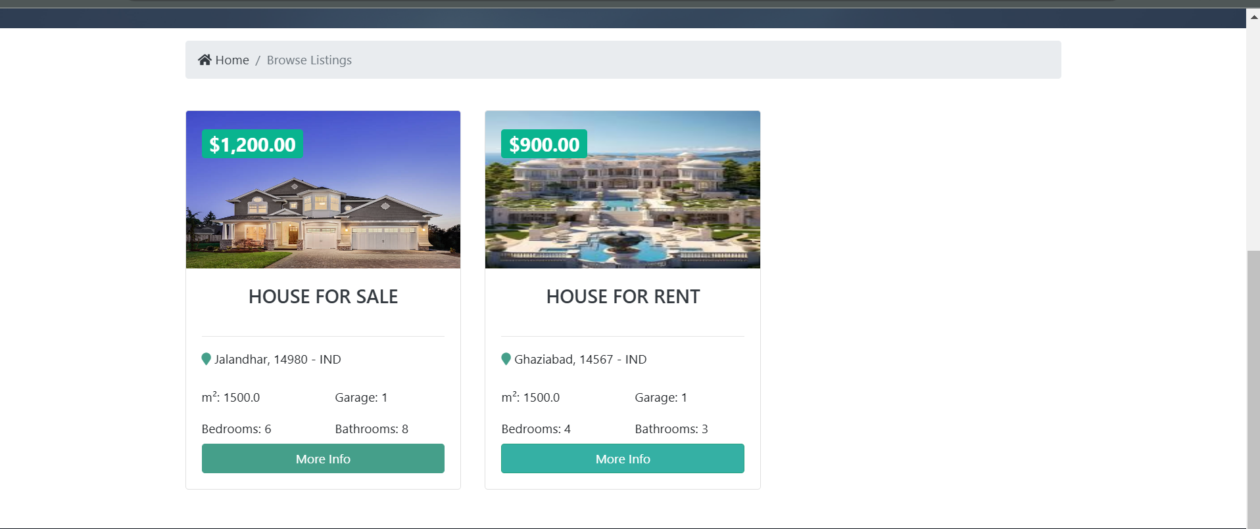

Fig 5.5 Featured Listings

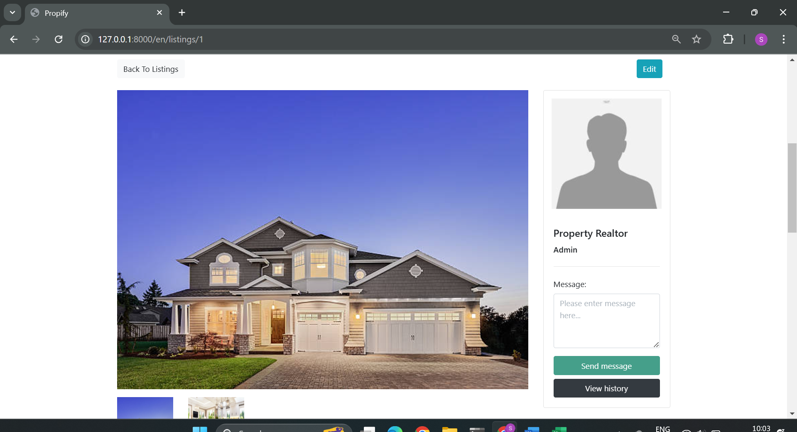

Fig 5.6 Listing Information

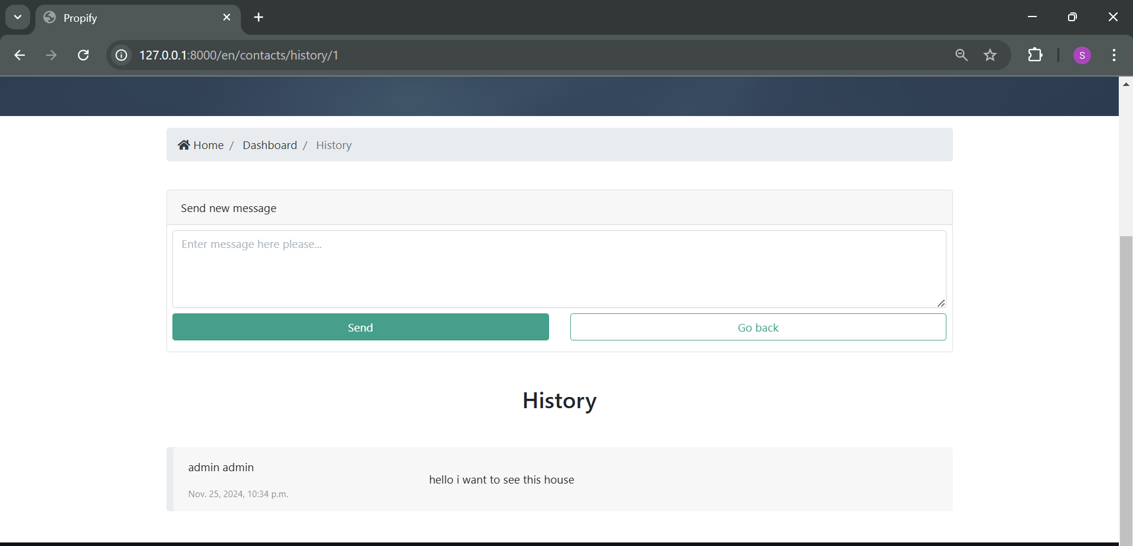

Fig 5.7 Inquiry History

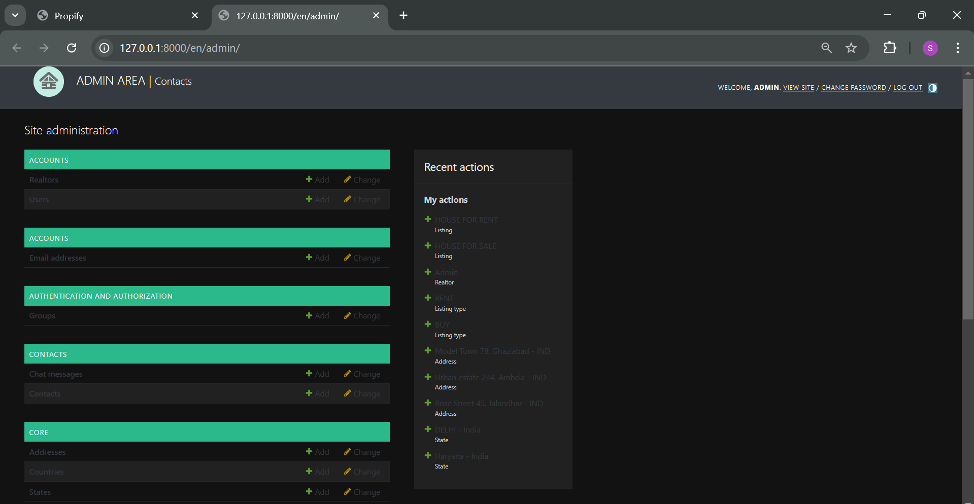

Fig 5.8 Admin Page

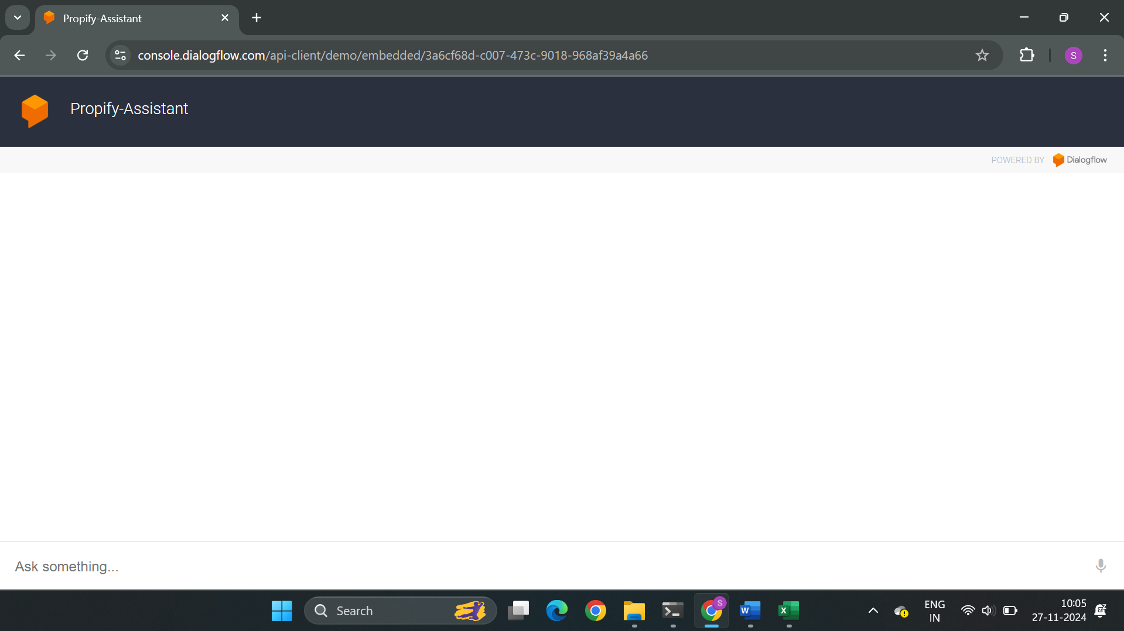

Fig 5.9 Chatbot interface

**6. Testing**

* 1. Test Plan

**1. Introduction**

This test plan outlines the approach, scope, resources, and schedule of testing activities for the Propify application, a platform for buying and selling properties. The primary focus is to ensure the core functionalities such as user registration, property listing, and property search work as intended.

**2. Objectives**

* Validate the Propify app's functionality, usability, and performance.
* Ensure core features like user authentication, property listing, and search are error-free.
* Identify and document any issues that arise during testing.

**3. Scope**

The following features of the Propify app will be tested:

1. User Registration
2. Property Listing
3. Property Search

**4. Testing Strategy**

**Test Levels:**

* **Unit Testing**: Conducted by developers to test individual components.
* **Integration Testing**: Verify interactions between modules like search filters and property listings.
* **System Testing**: Validate end-to-end functionality as a complete system.

**Testing Types:**

* **Functional Testing**: Ensuring the app’s features behave as expected.
* **Usability Testing**: Confirming the user interface is intuitive.
* **Regression Testing**: Ensuring new features do not affect existing functionality.

**Testing Approach:**

Manual testing will be conducted to verify core functionalities.

**5. Roles and Responsibilities**

* **Test Manager**: Oversees the testing process, defines strategies, and ensures adherence to deadlines.
* **Tester(s)**: Executes test cases, reports issues, and retests fixed bugs.
* **Developer(s)**: Fixes defects identified during testing.

**6. Test Environment**

* **Browser Compatibility**: Chrome, Firefox, Edge
* **Operating Systems**: Windows, macOS
* **Devices**: Desktop, mobile, and tablets

**7. Entry & Exit Criteria**

**Entry Criteria:**

* The application is deployed to the testing environment.
* All dependencies and prerequisites are available.

**Exit Criteria:**

* All planned test cases are executed.
* All high-severity defects are resolved.

**8. Deliverables**

* Test Cases
* Bug Reports
* Test Report
  1. Test Cases

**TEST CASE- 1**

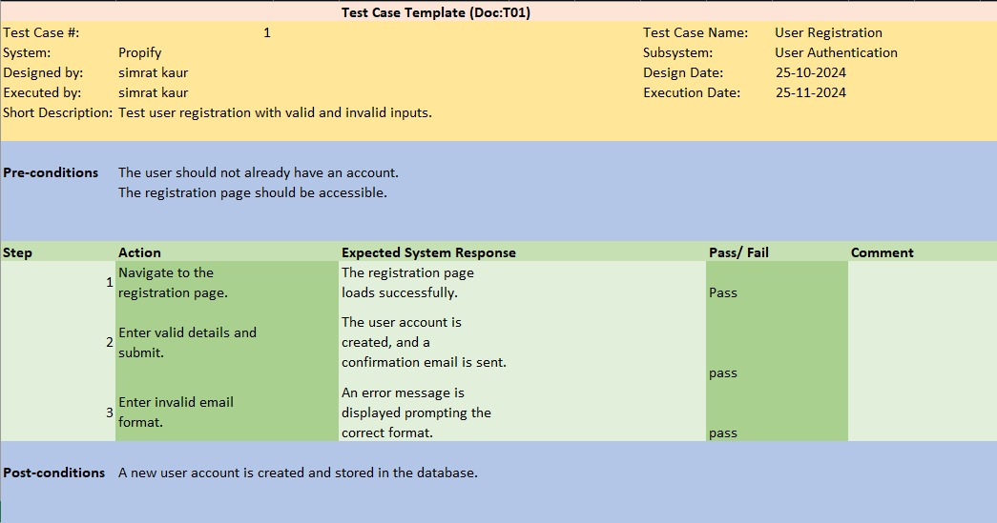

**TEST CASE- 2**

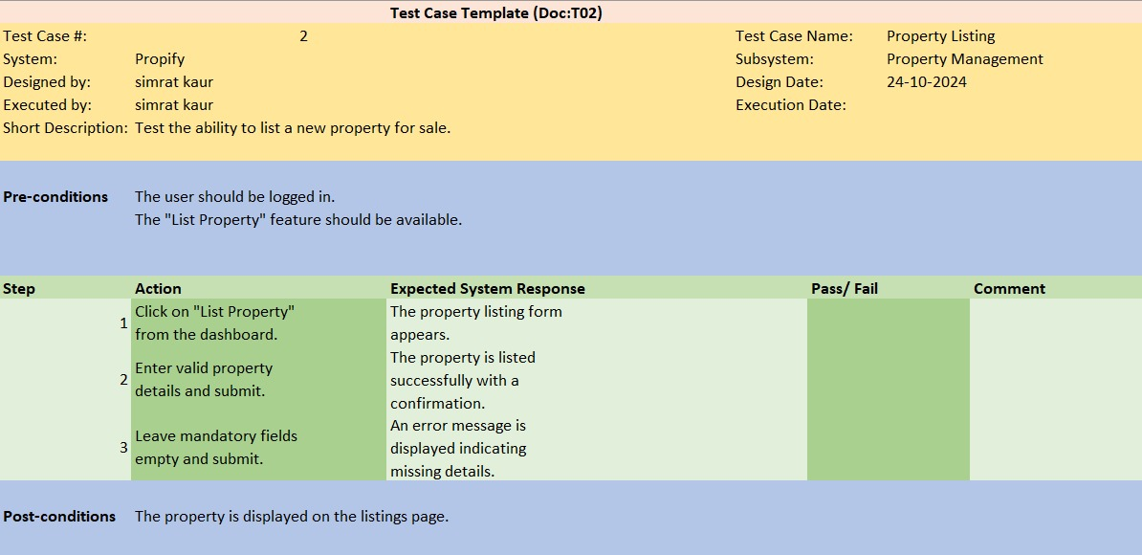

**TEST CASE- 3**

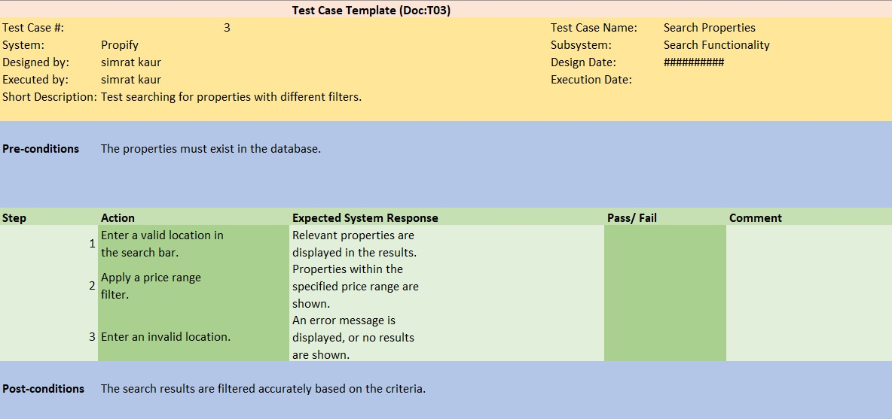

**TEST CASE- 4**

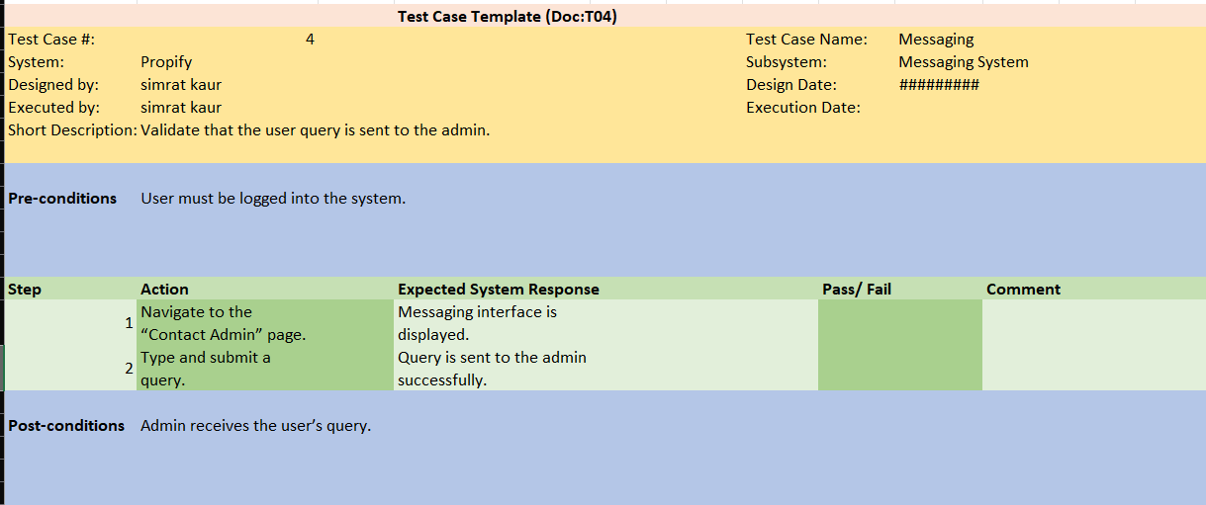

**TEST CASE- 5**

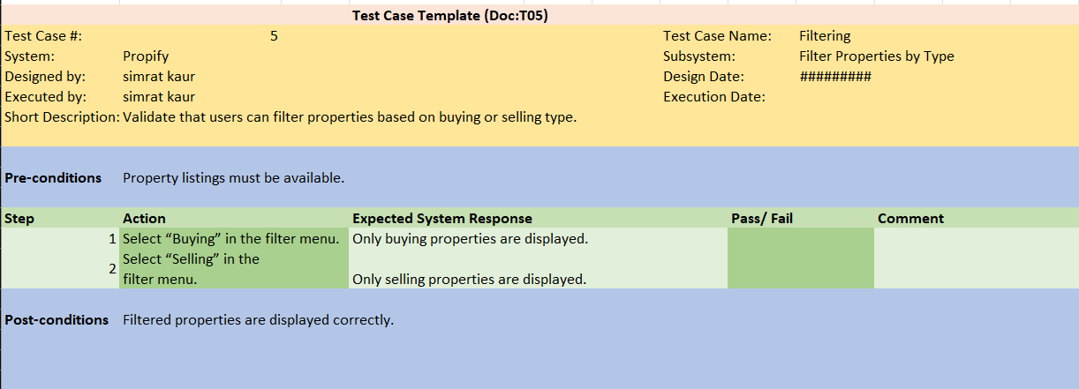

**TEST CASE- 6**

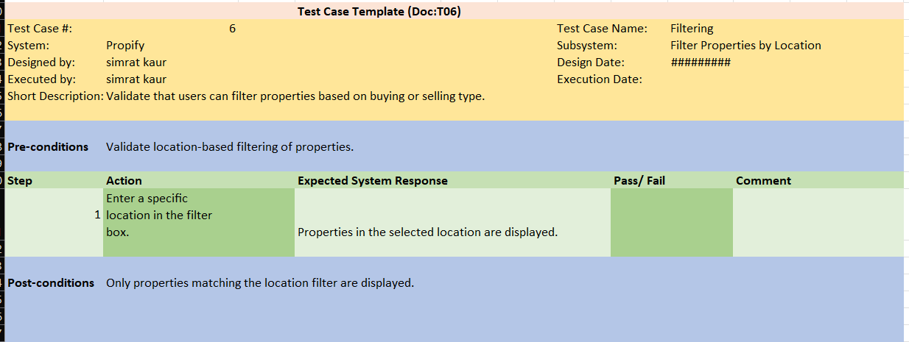

**TEST CASE- 7**

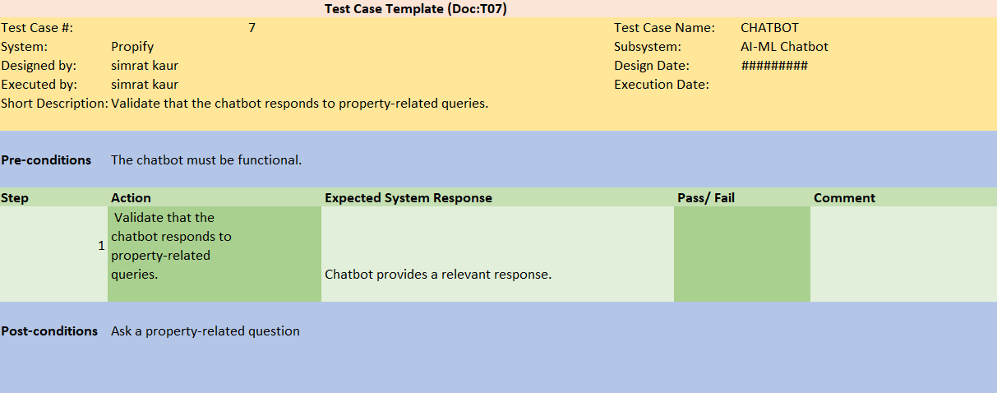

**TEST CASE- 8**

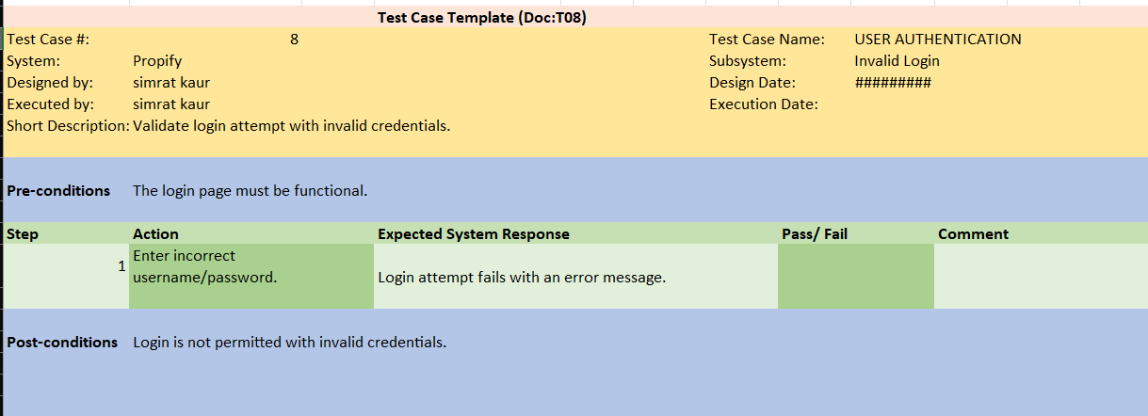

* 1. Test Reports

**1. Summary**

Testing was conducted on the Propify app's core functionalities, including user registration, property listing, and property search. Most features performed as expected, with a few minor issues identified and logged.

**2. Observations**

* The application is stable and functional for most cases.
* Minor UI alignment issues were noted but do not affect core functionality.
* Performance improvements needed for large datasets in search.

**3. Recommendations**

* Fix UI alignment issues on the registration page.
* Optimize database queries for faster pagination.

1. **Conclusion-**

The Propify app passed most test cases successfully, indicating readiness for deployment after addressing minor issues.